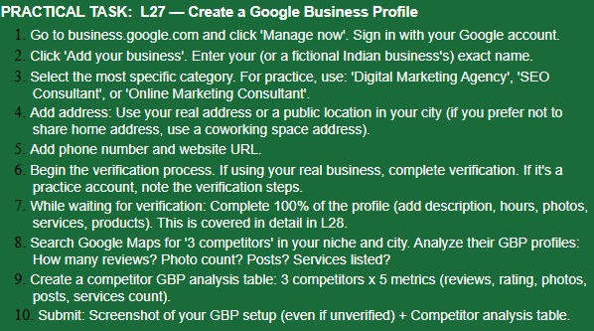
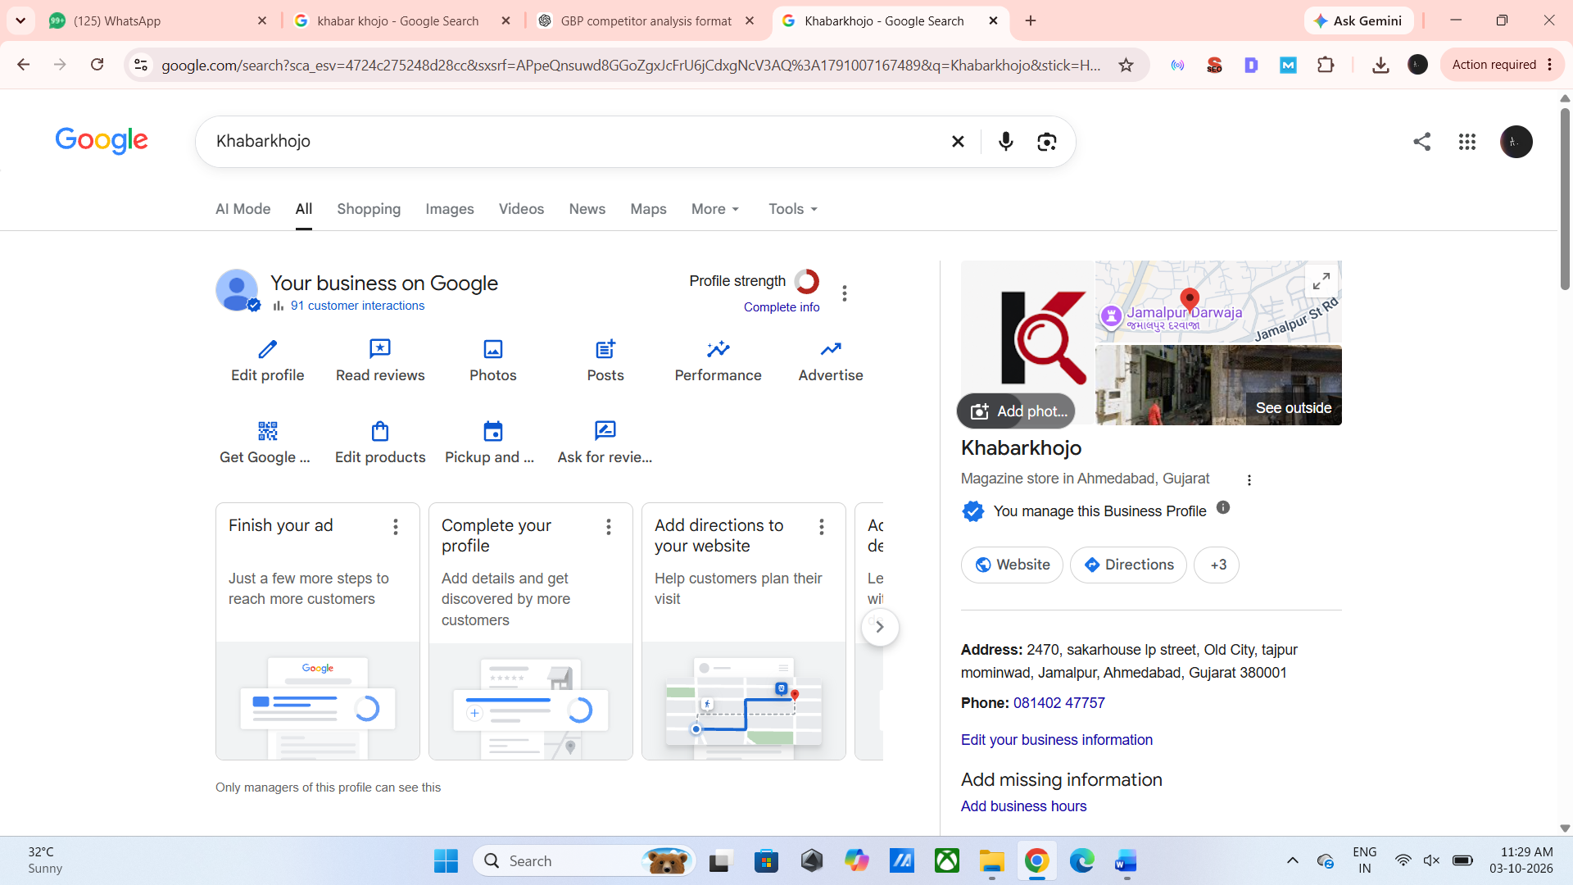
No. | Competitor | Reviews | Rating | Photos | Posts | Services
1 | The Indian Express | 12 | 4.5 | Check Maps | Check Maps | News / Newspaper Publishing
2 | Khabarpatri | 55 | 5.0 | Check Maps | Check Maps | News & Media Services
3 | Hindustan Times | Check Maps | Check Maps | Check Maps | Check Maps | News / Media Services
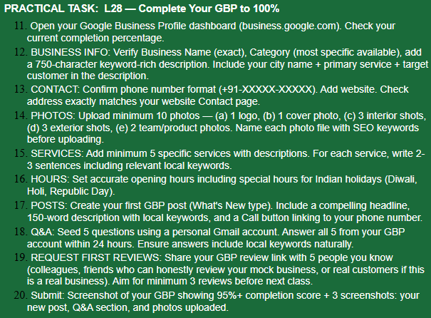

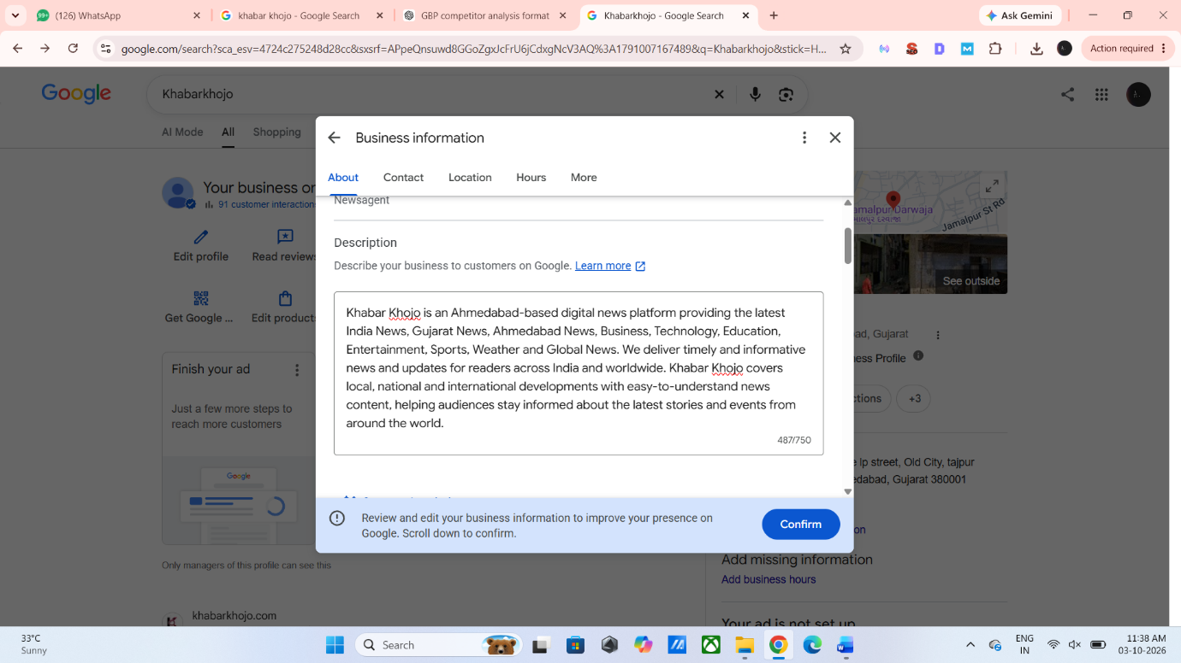

Before : 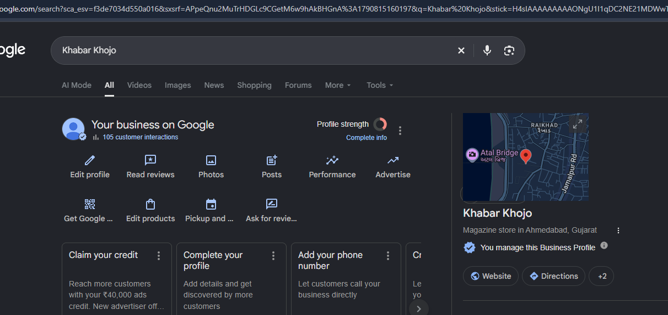
After: 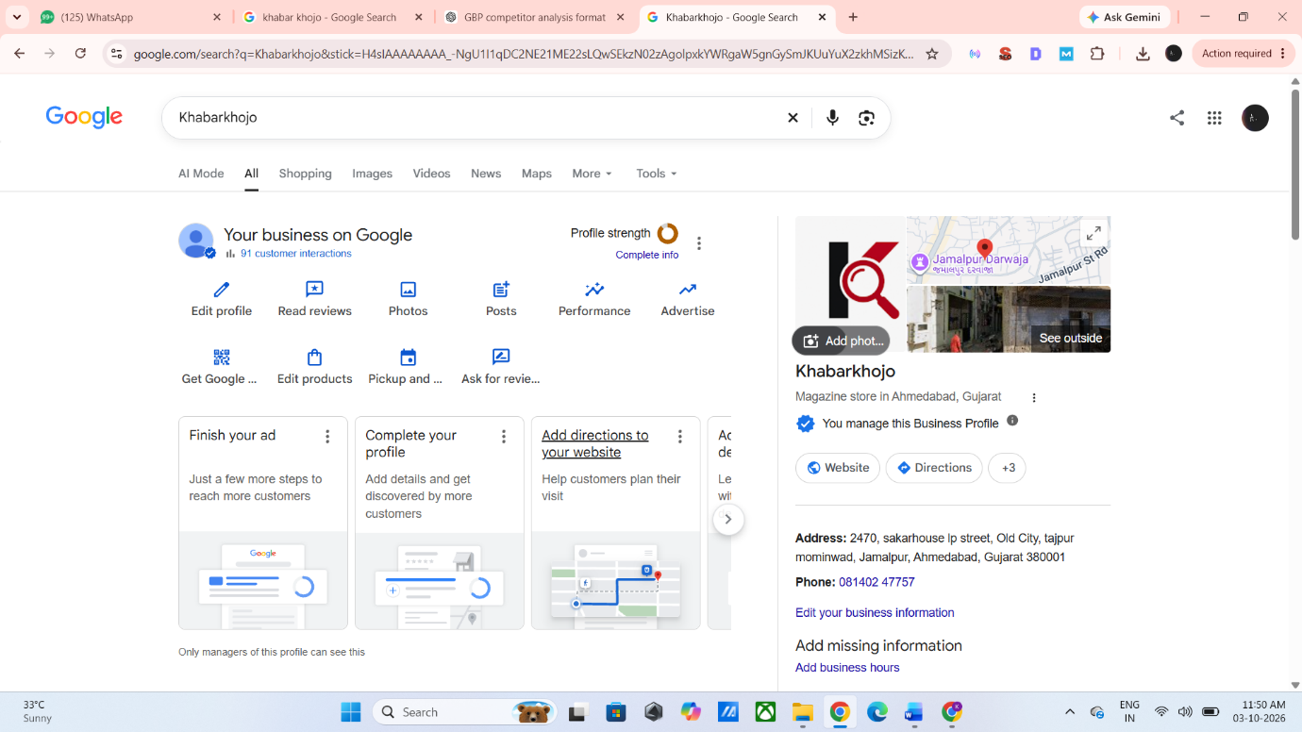

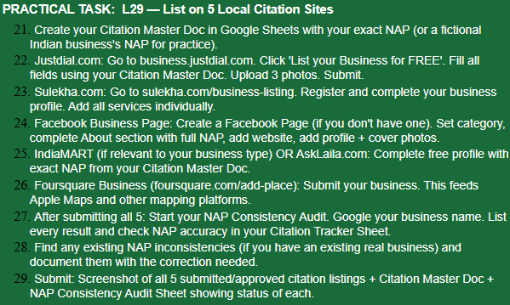
No. | Citation / Platform | Khabar Khojo | Presence Type
1 | Google Business Profile | Available | Google Business Profile
2 | Facebook | Available | Social Media / Business Page
3 | Twitter/X | Available | Social Media Profile

Note ; Khabar Khojo has an existing presence on Google Business Profile, Facebook and Twitter/X. These platforms were selected as relevant online citation and social presence sources for the digital news platform.

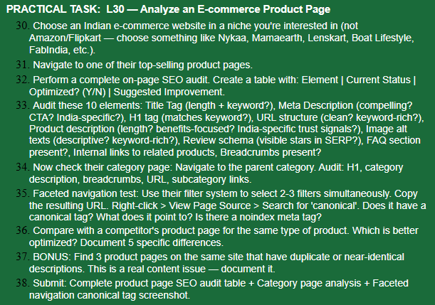
Selected E-commerce Website
Website: PALMONAS
Niche: Jewellery
Selected Product: Solitaire Drop Hoop Earrings
Product URL: https://palmonas.com/products/solitaire-drop-hoop-earrings-64348
The product was selected because the PALMONAS product page currently displays “132 quantity sold in last 7 days,” indicating that it is a high-selling product.
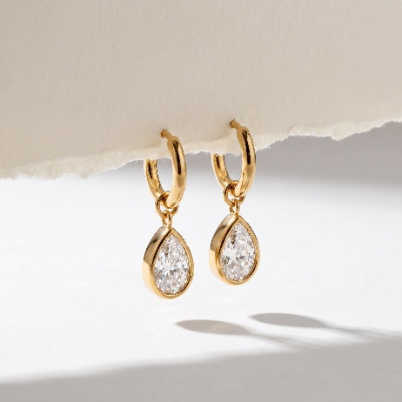
On-Page SEO Audit
SEO Element | Current Status | Optimized? | Suggested Improvement
Title Tag | “Buy Solitaire Drop Hoop Earrings online- Palmonas – PALMONAS” | Yes | Keep the main keyword but make the title shorter and more attractive.
Meta Description | Product-focused description is available | No | Add a compelling CTA and important keywords such as 18K gold tone, anti-tarnish and buy online. And its too long.
H1 Tag | “Solitaire Drop Hoop Earrings” | Yes | H1 matches the main product keyword.
URL Structure | /products/solitaire-drop-hoop-earrings-64348 | Yes | Clean URL with the main product keyword.
Product Description | Detailed description with product features and styling information | Yes | Add related keywords naturally, such as gold hoop earrings and earrings for women.
Image Alt Text | Alt text includes terms such as “Anti tarnish”, “Skin Safe Jewellery” and “18K Gold Tone Plated” | Partially | Use product-specific alt text such as “Solitaire Drop Hoop Earrings 18K Gold Tone”.
Review Schema | Review/star display in Google SERP could not be confirmed from the page audit | Needs Verification | Check Google's SERP and page source for Product/Review structured data.
FAQ Section | No dedicated product FAQ section found | No | Add FAQs about material, care, anti-tarnish, delivery and returns.
Internal Links | Related products are displayed on the page | Yes | Continue adding relevant category and related-product links.
Breadcrumbs | Breadcrumb structure was not clearly visible in the page content | Needs Verification | Add/verify breadcrumbs such as Home → Jewellery → Earrings → Product.
The product page contains detailed product information including 18K gold tone plating, cubic zirconia, waterproof and anti-tarnish features, as well as Indian styling suggestions such as sarees, lehengas and Anarkalis
Parent Category Page Analysis
Category Page: PALMONAS – Hoop Earrings
Element | Analysis
H1 | Category page focuses on hoop earrings and lists multiple hoop products.
Category Description | Product listings are provided; category-level descriptive SEO content can be improved if required.
Breadcrumbs | Should be checked on the live page/source.
URL | /collections/hoop – short and keyword-relevant.
Subcategory/Product Links | Multiple related hoop earrings are internally linked from the category page.

Suggested SEO Improvements
- Add a stronger, keyword-focused meta description with CTA.
- Improve image alt text using descriptive product keywords.
- Add a dedicated FAQ section.
- Verify and implement Product/Review schema.
- Add or verify breadcrumb navigation.
- Add more contextual internal links between product and category pages.
The PALMONAS product page has a strong basic on-page SEO structure, including a keyword-focused H1, clean URL, detailed product content and internal product links. Some areas such as FAQ, image alt-text optimization, structured-data verification and breadcrumb implementation can be improved.

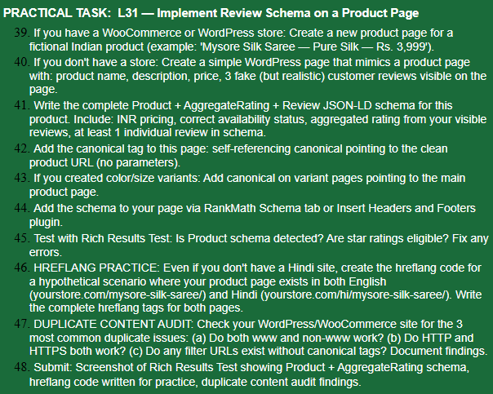
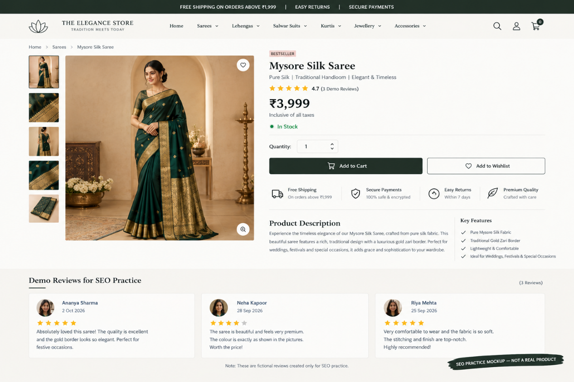
Note ; I do not currently have an e-commerce website like this. However, I have knowledge of On-Page SEO, so I completed this task as a practice exercise.

